**INSTALLING WINDOWS OPERATING SYSTEM BY CREATING BOOTABLE PENDRIVE**

To install Windows 10 from Linux using WoeUSB (or similar tools), you can follow these steps. This process involves creating a bootable Windows 10 USB drive from Linux and then using that USB to install Windows 10.

### **Step 1:** **Download the Windows 10 ISO**

Here i want to install **WINDOWS 10** operating system on my **LINUX** desktop. Windows 10 is an operating system developed by Microsoft for personal computers, tablets, embedded devices, and internet of things devices.

* Download the official Windows 10 ISO file from the [Microsoft website](https://www.microsoft.com/en-us/software-download/windows10ISO).

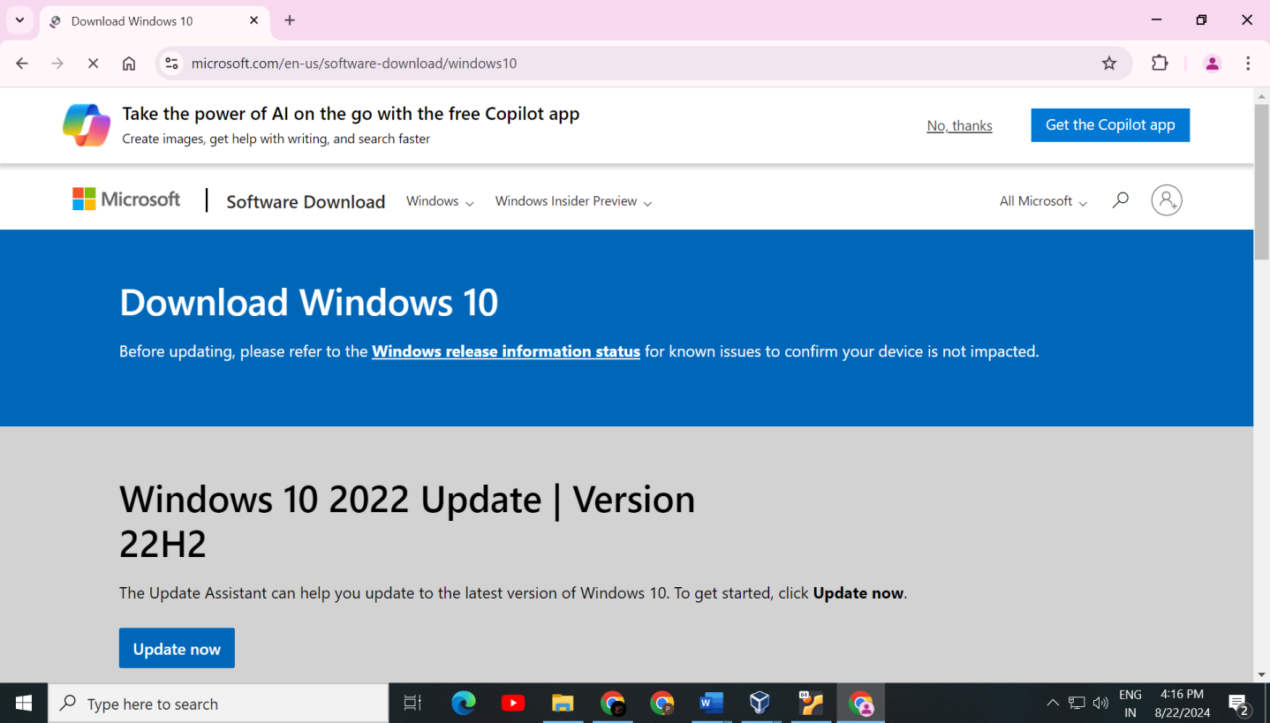

**Step 2:**

**BACKUP YOUR DATA**

Ensure all important data is backed up as the installation process will likely overwrite existing data on the target drive

**Step 3:**

**Install WoeUSB**

WoeUSB is a tool to create bootable USB drive.

For Ubuntu-based distributions, I can add the WoeUSB repository using the following commands:

**sudo add-apt-repository ppa:tomtomtom/woeusb** (we use this command to add package archive of WoeUSB.)

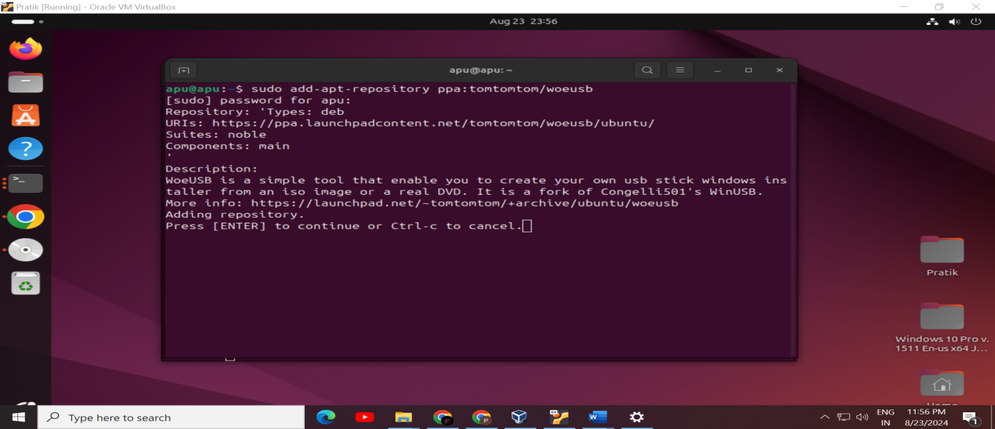

**Update package**

Update the package by **‘sudo apt update’** command

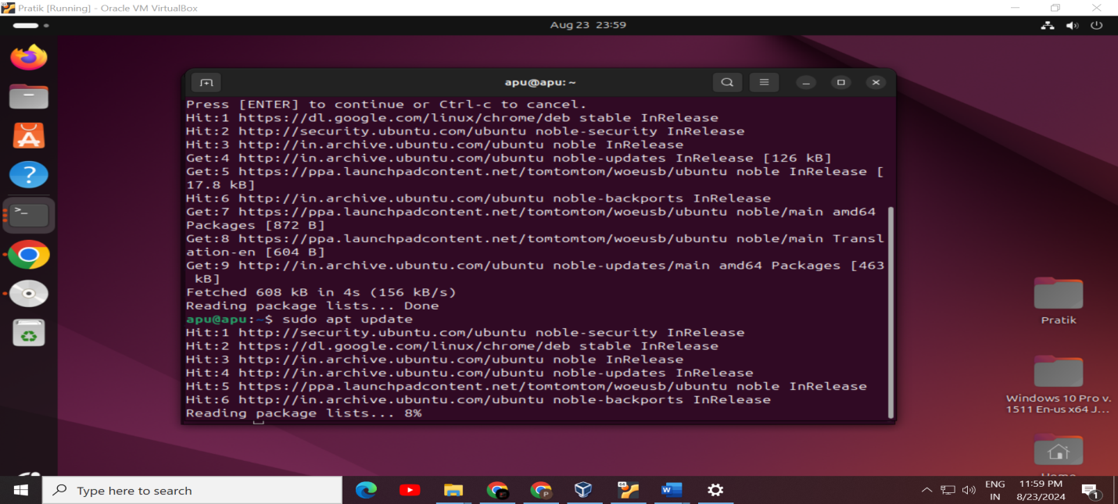

**Install WoeUSB**

Install WoeUSB by running : ‘**sudo apt install WoeUSB-frontend-wxgtk’**

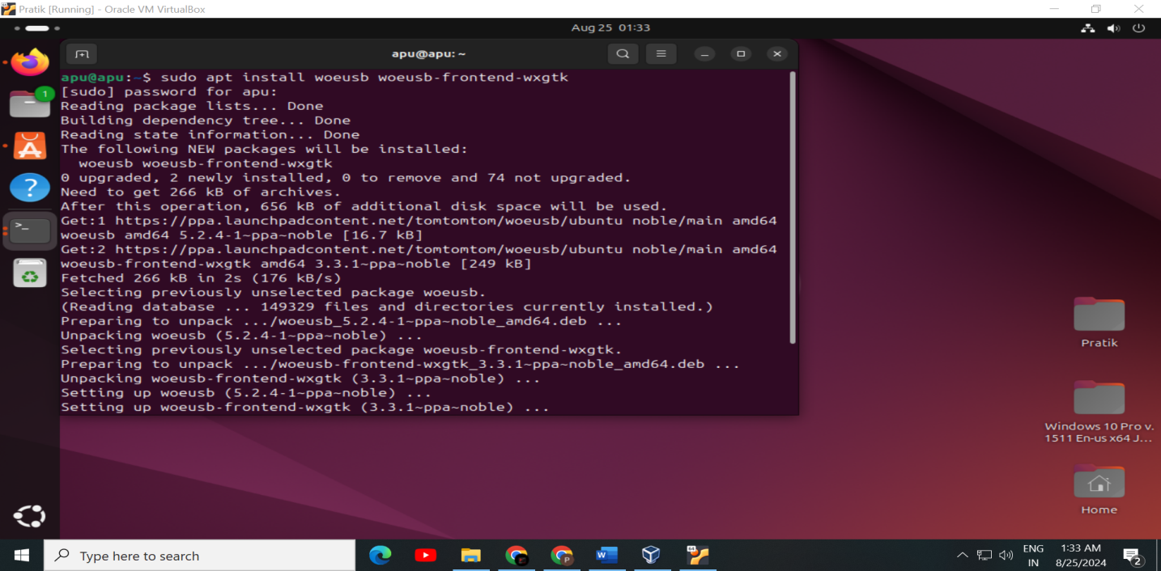

**Step 4:** Insert USB Drive. check the usb drive is connected by command **df -h.**

/dev/sdb1 is showing, here **sdb1** is my USB

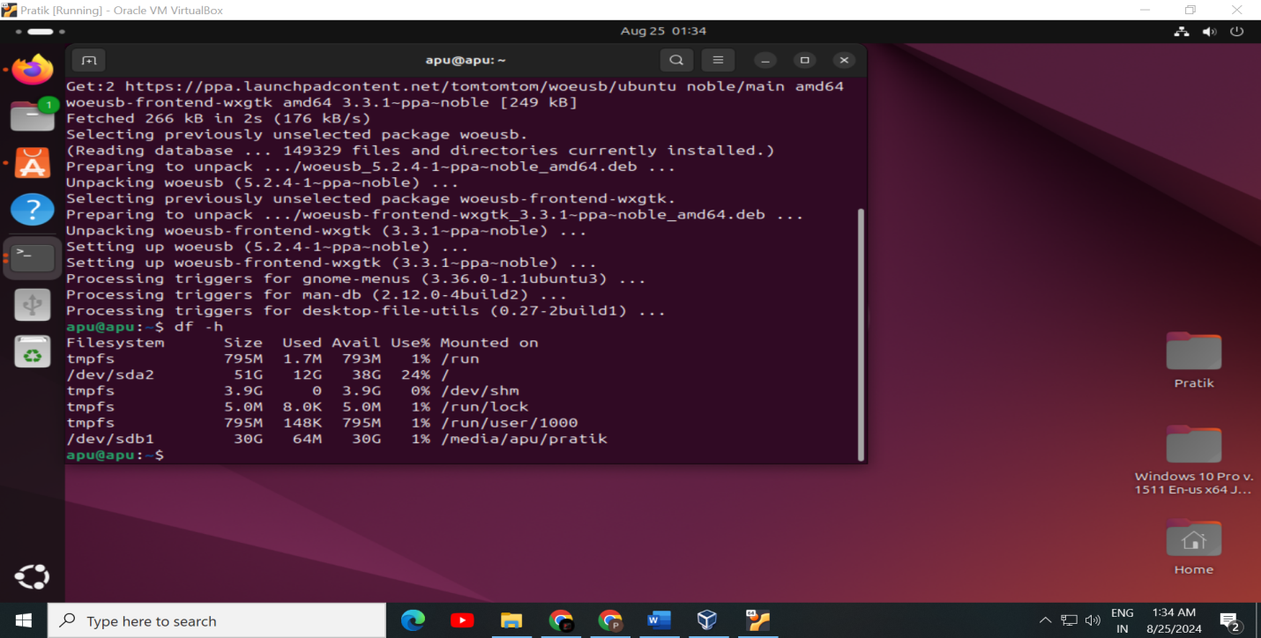

**Step 5:** Unmount the USB Drive using command **sudo umount /dev/sdb1,** before make USB Drive bootable. Run **df -h** command again to check if my USB Drive is unmounted or not. Here /dev/sdb1 is not showing in the list that mean my USB Drive is unmounted.

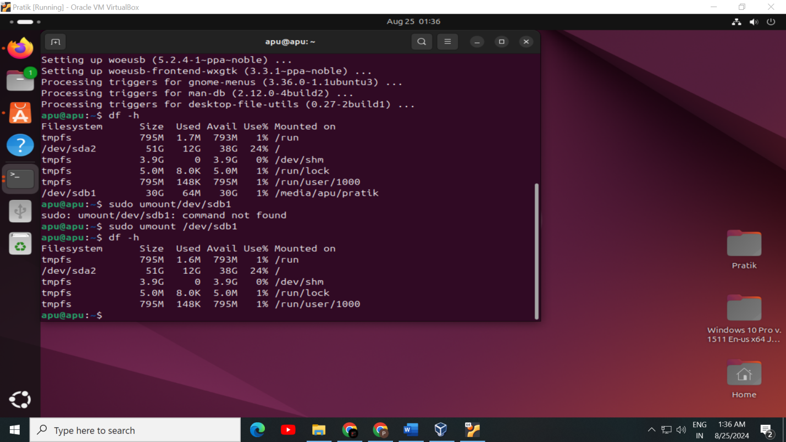

**Step 6:** Now open WoeUSB and select the Windows 10 ISO file in Disk image section. Select my USB Drive in Target device section. Next, choose NTFS as filesystem.

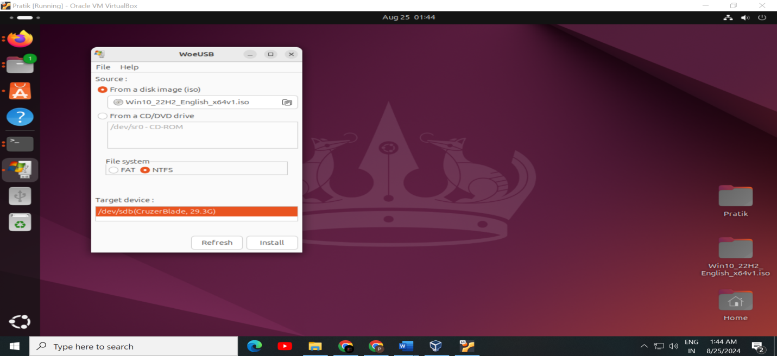

**Step 7:** Verify Authentication by putting the password of computer system and click on Authenticate option.

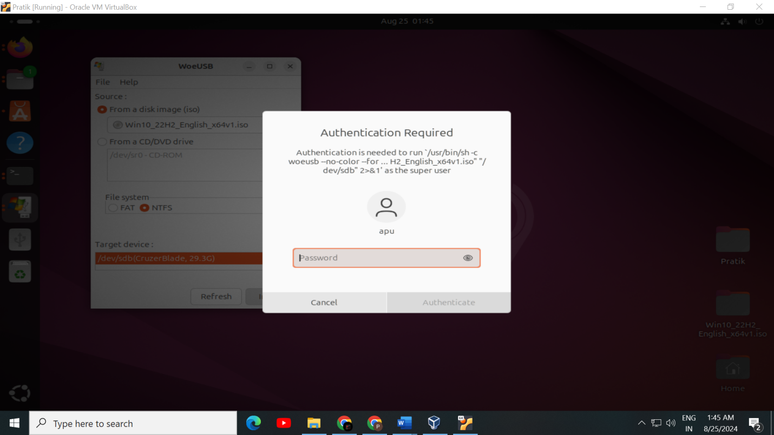

After Authentication, Installation process has been started

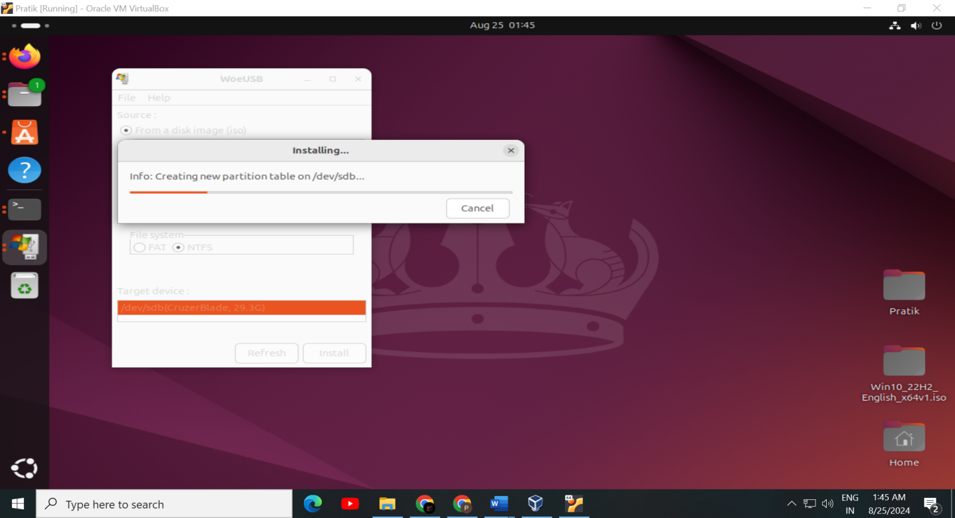

Finally, USB drive has become bootable.

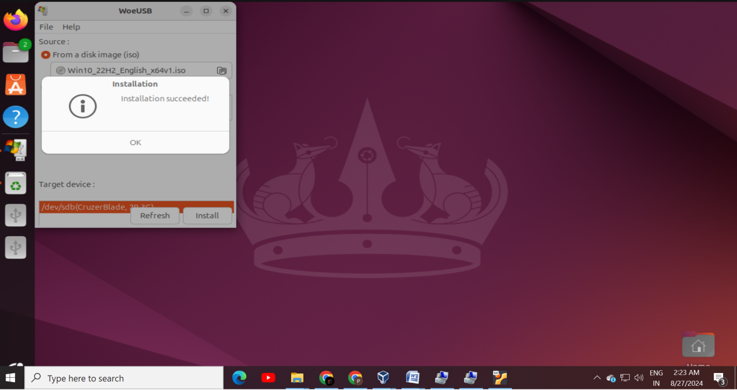

**Step 8:**

### **Change Boot Order in BIOS/UEFI**

* Restart your computer and enter the BIOS/UEFI settings (commonly by pressing F2, F10, Delete, or Esc during startup).
* Change the boot order to prioritize booting from the USB drive

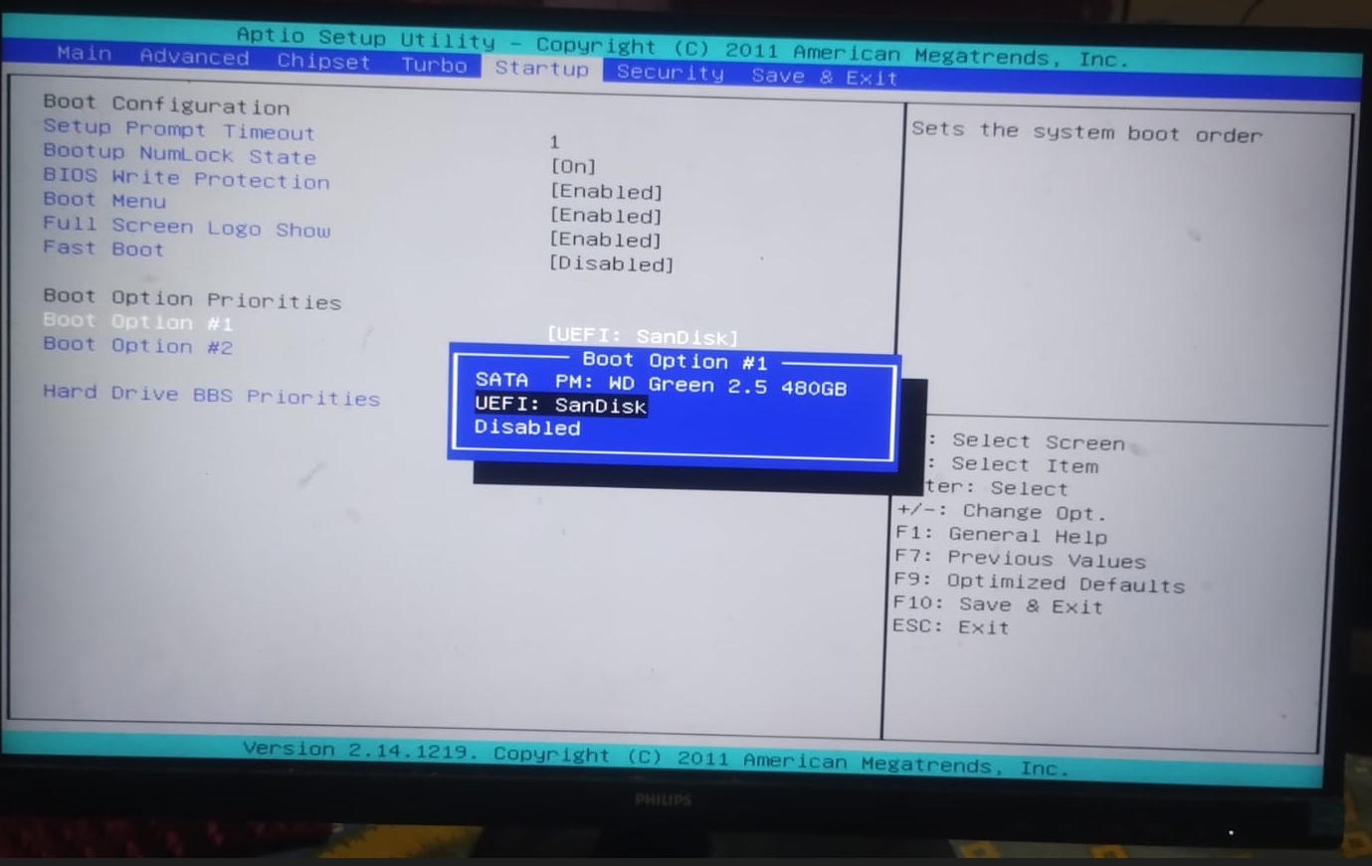

**Step 9:**

### **Install Windows 10**

Follow the on-screen instructions to install Windows 10:

• After booting from the USB drive, the Windows 10 installation screen will appear. Select your language, time, and keyboard preferences, then click "Next."

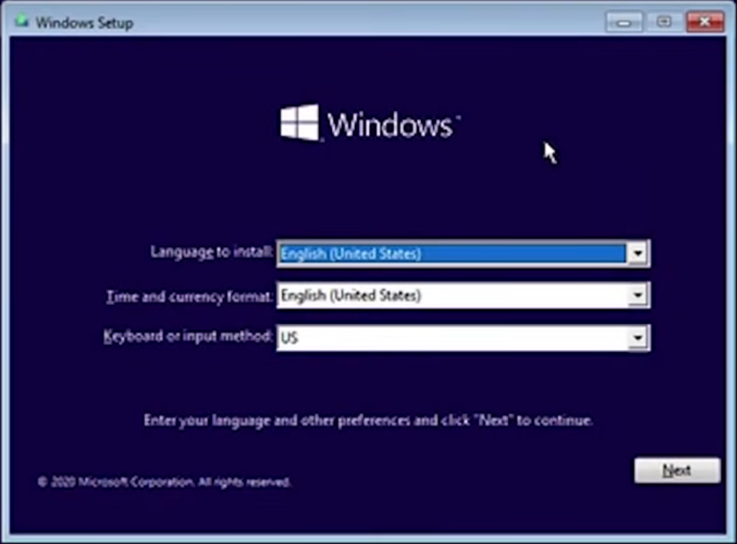

**Enter the Product Key:**

* Enter your Windows 10 product key. If you don’t have one, select "I don’t have a product key" and proceed. You can activate Windows 10 later.

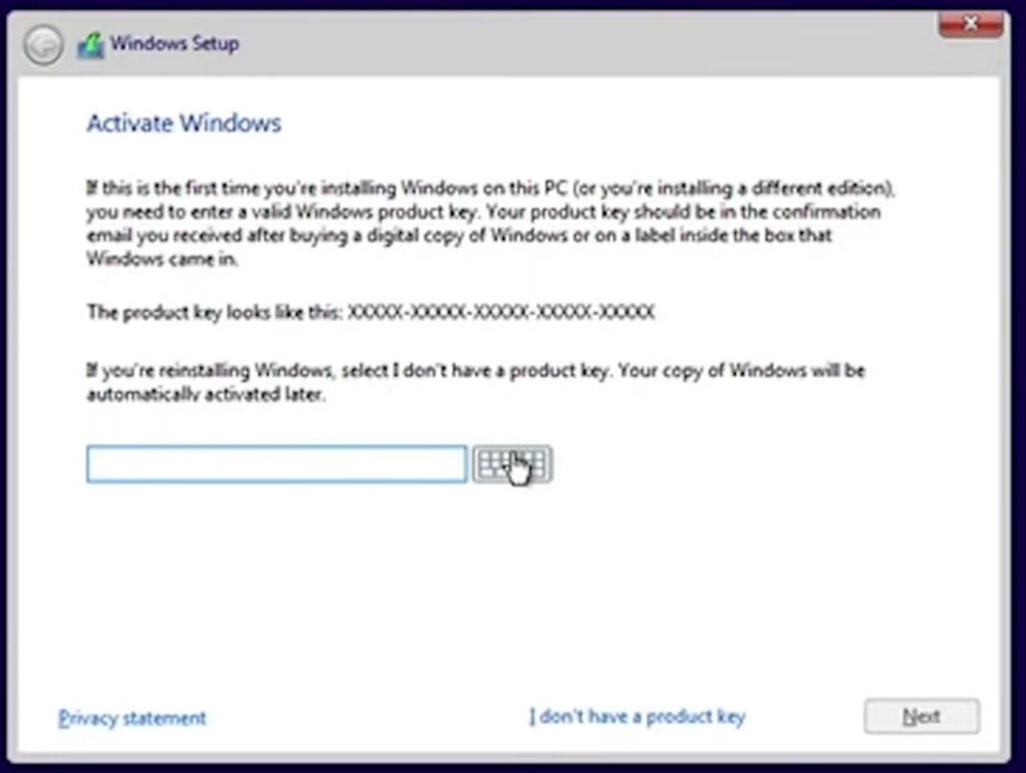

**Select Installation Type:**

* Choose "Custom: Install Windows only (advanced)" for a clean installation.

## 

**Partition the Drive:**

* Select the drive where you want to install Windows 10. If you’re installing on a new drive, just select it and click "Next."
* If you need to create or delete partitions, do so on this screen.

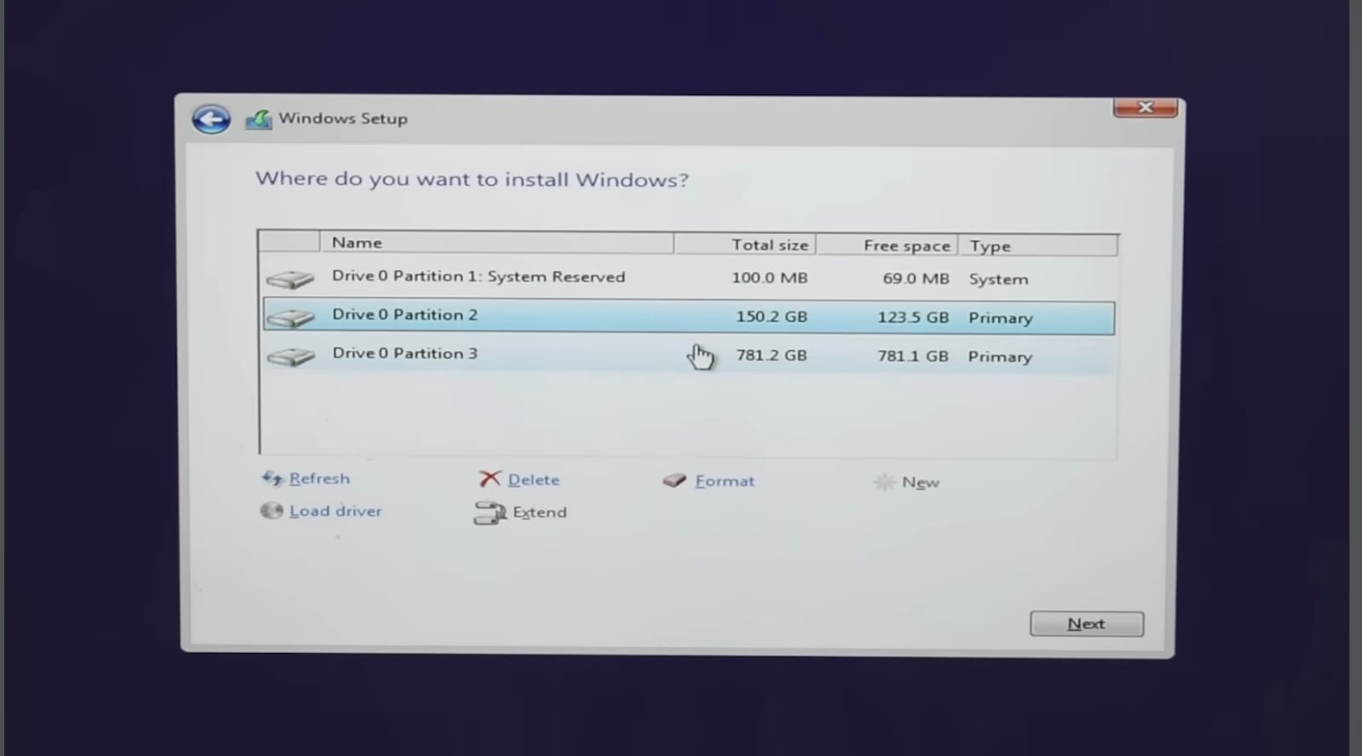

**Begin Installation:**

* Windows will start copying files and installing the OS. This process may take some time and the computer will restart several times.

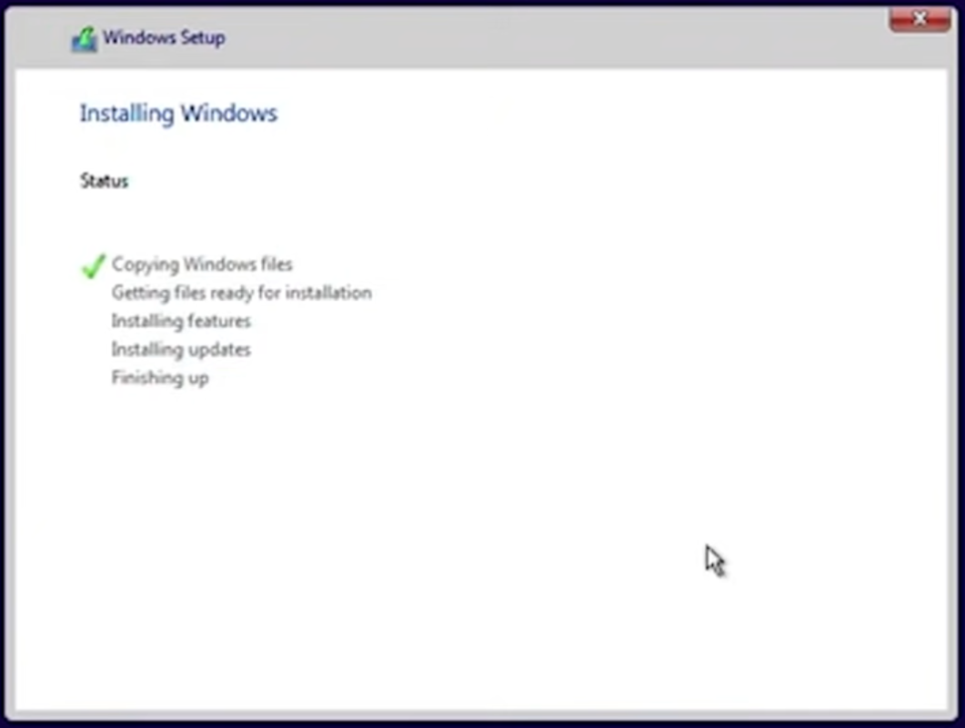

**Step 10:**

### **Complete the Setup**

After installation, you’ll need to configure Windows 10 settings.

**Set keyboard layout:**

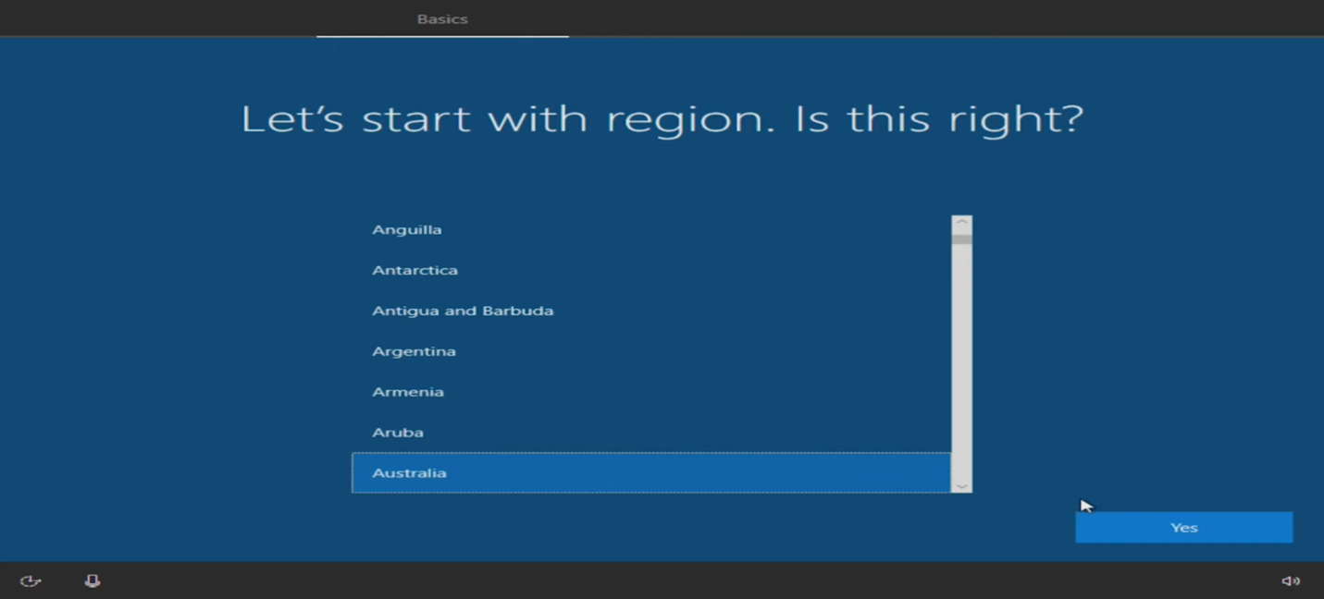

**Connect to Wi-Fi:**

If not already connected, you’ll be prompted to connect to a network

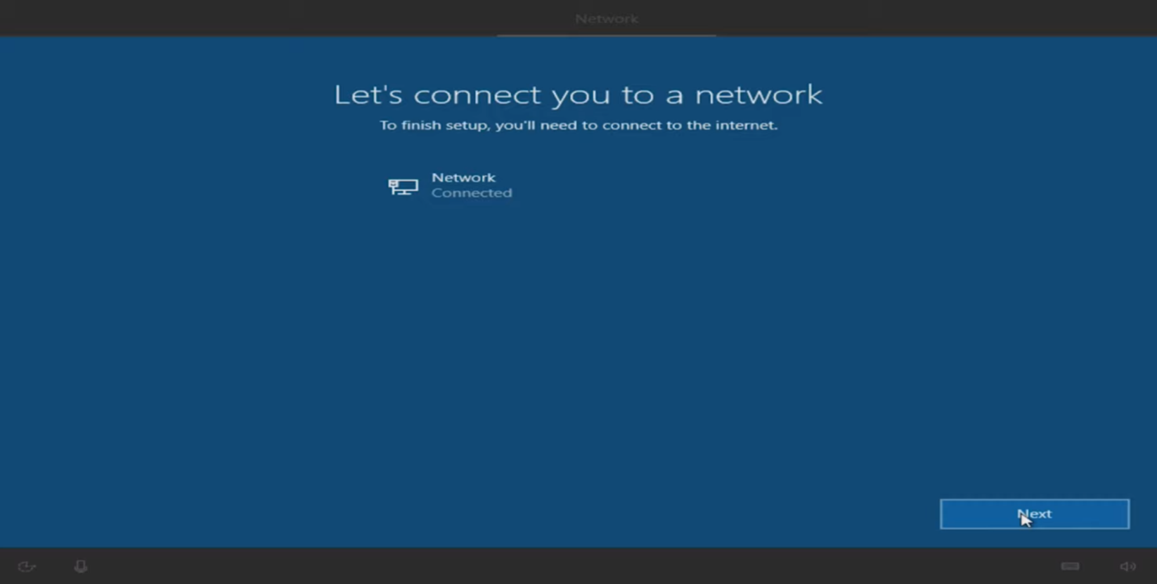

• Create **a User Account:**

Set up a user account with a name and password.

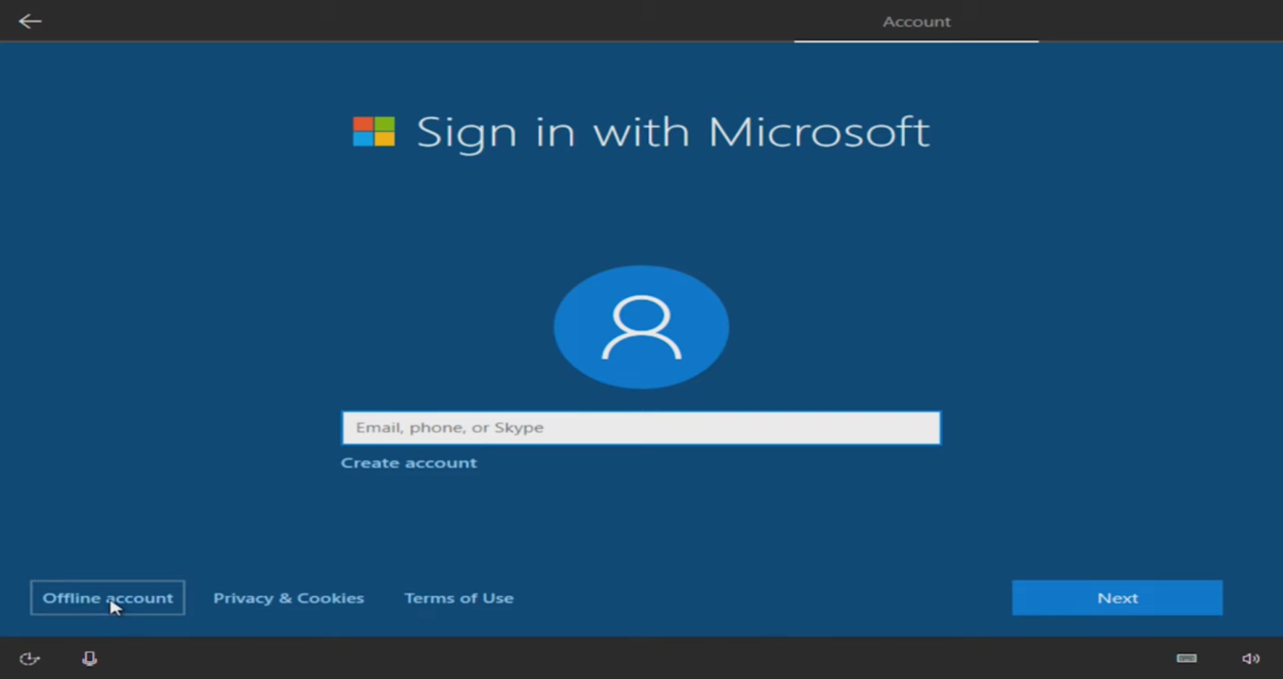

**Windows 10 will finalize your settings and load the desktop.**

**Step 11:**

### **Activate Windows and Install Updates** After installation, ensure that Windows 10 is activated and updated.

**Steps:**

1. **Activate Windows:**
   * Go to "Settings" > "Update & Security" > "Activation."
   * Enter your product key if you haven’t already done so.
2. **Install Updates:**
   * Go to "Settings" > "Update & Security" > "Windows Update."
   * Check for updates and install any available updates.

### **Conclusion:**

You’ve successfully installed Windows 10 on your PC. From here, you can install your preferred software, transfer your files, and customize the OS to your liking.